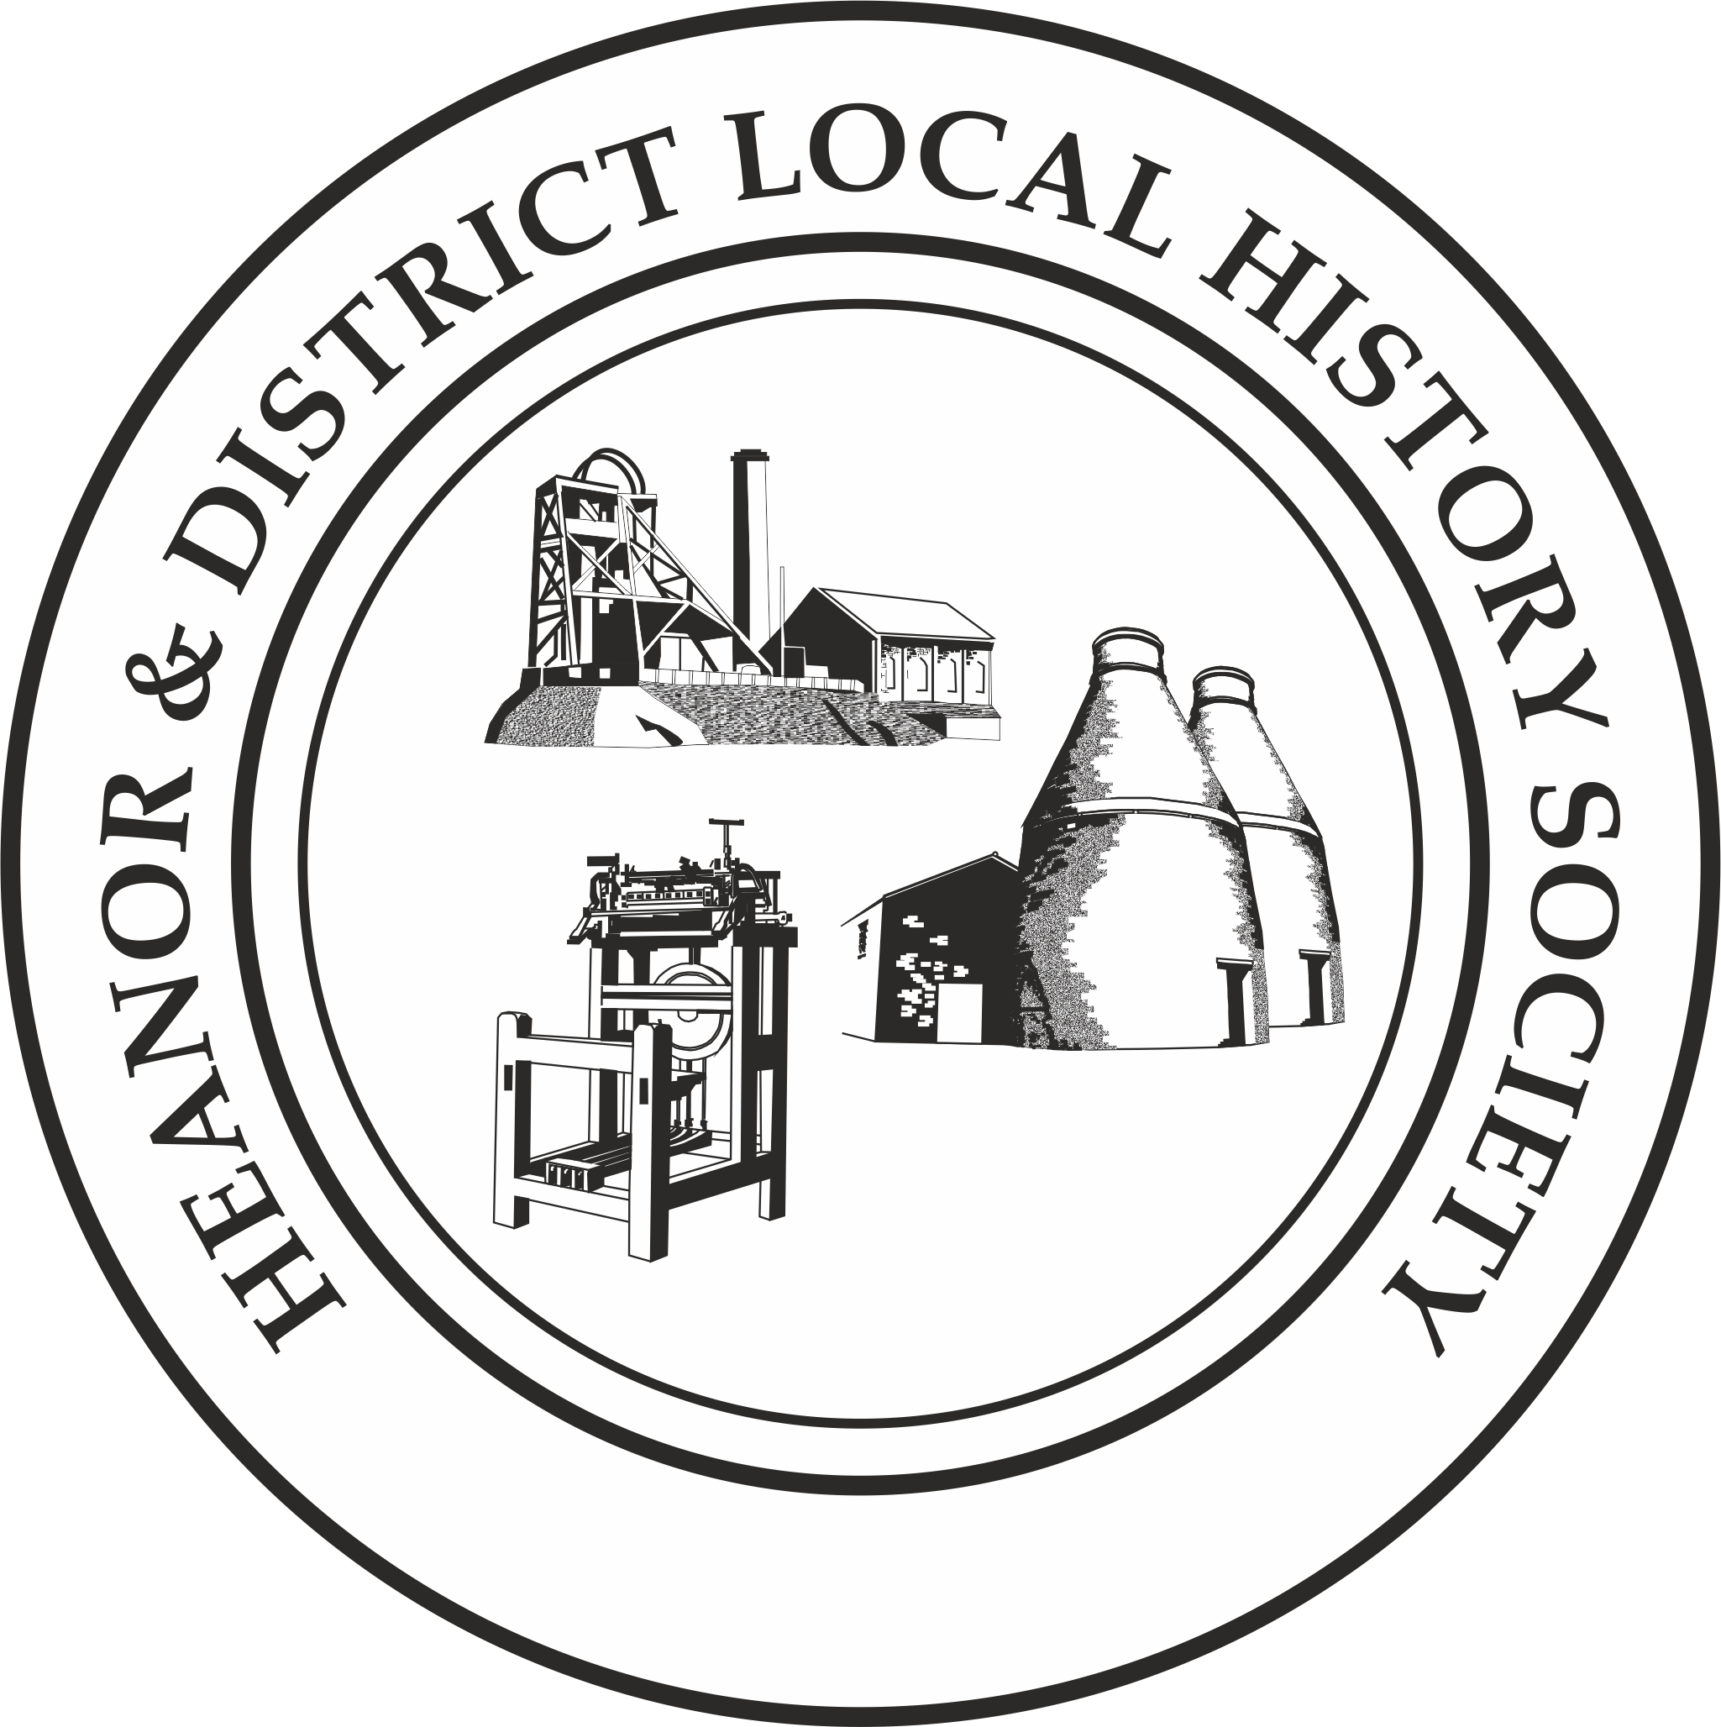
We want your memories! As part of an ongoing project, the Heanor & District Local History Society wants to hear from YOU.
This month’s topic is: Doctors and Health
If you normally attend our meetings, just fill in the form and hand it back at the next meeting.
If you don’t attend our meetings, then you can send us an email with the information (mail@heanorhistory.org.uk), or post the form to 12 Walton Court, West Hallam, Ilkeston, DE7 6NS.
We would rather that you didn’t send us information anonymously, but nobody’s name will be published unless you have specifically given us permission to do so. In particular, we WILL NOT publish anything which is of a personal or potentially sensitive nature.
Name | Address
Telephone
Email address
Are you willing for us to include your name if we publish your memories? |  | Yes / No
Would you be prepared to discuss this or related information further? |  | Yes / No

In this questionnaire, we would like you to think back to either childhood or your early adult life, and tell us what you remember about your doctors.
A few of our members will remember the days before the National Health Service, and will have memories about payments to go for medical help, etc. – there are no questions specifically about this, but we would really like you to tell us what it was like.
PLEASE do not tell us about any medical issues you may have had.
Roughly what period are you remembering (year/decade)?

Who was/were your doctor(s) – where was the surgery?

How did you arrange an appointment?
Please describe the waiting room. How are things different today?

How, if at all, has the relationship between you and your doctor changed from then to now?

If you were prescribed any medicine, where did you collect it from? How have pharmacies changed?

Please describe a memorable visit to/by a doctor (again, do not describe the medical reasons for it).
Please use a separate sheet if necessary. Thank you

